Integrating the Arts
www.integratingthearts.yolasite.com
By: Natalie Paasch
Title: Revolutionary War Mobile
Grade Level: 5th
Subject: Social Studies
Content Covered: Revolutionary War
Materials Needed:
- 3-4 wood skewers per student with points trimmed or sanded off
- Glue
- String (about 3 feet per student)
- Card stock, construction paper, cardboard, tissue paper
- Scissors
- Coloring utensils
Procedure:
- Have students decide on 4 to 5 figures to make that will hang on their mobiles. The figures may be 2D or 3D. The figures can vary in size ranging from about 2 inches to 6 inches. It is easier to balance the mobile if the figures are close to the same weight. You may let the students be creative with the materials they use to make their figures. The figures should be related to the Revolutionary War. You could have students pick two people that were important to the Revolutionary War, an incident that led to the Revolutionary War, an important battle fought during the Revolutionary War, and an effect of America winning the Revolutionary War for example. Students would have to make a figure to represent those items. Students will have to be able to explain why they chose the figure they did and its significance to the Revolutionary War.
- Once students have their figures made they need to construct their mobiles.
  - Poke a small hole in the top of each figure. Be careful not to poke the hole too close to the edge of the figure. You may use a pencil, skewer, or hole punch to make the hole.
  - Tie a 4-6 inch piece of string to each figure. Make sure to double knot it.
  - You will start constructing at the bottom of your mobile. Tie a figure to each end of the bottom skewer. When you tie the string to the skewer it is very important that you wrap the string around the skewer 3 times and then tie the knot twice and then add a dab of glue and rub it into the string to hold the string in place so that it does not slip around on the skewer.
  - Hold up the skewer and find the balance point by balancing it on your finger. Mark this spot. This will be the spot that you will tie a sting to connect the next higher skewer.
  - Connect the balance point spot with the end of the second skewer by wrapping the string 3 times, double knotting, and gluing in place the string.
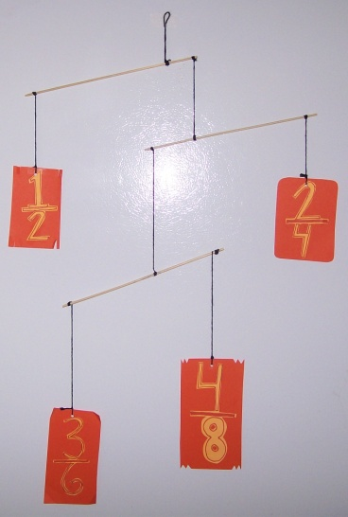
  - Connect your third figure to the end of the second skewer. Use the wrap, tie, glue technique.
  - Hold up the mobile and find the balance point of the second skewer by balancing it on your finger. Mark this spot.
  - Tie the end of your third skewer to the balance point using the wrap, wrap, wrap, tie, tie, and glue technique.
  - Attach the fourth figure to the end of the third highest skewer. Wrap, tie, glue.
  - Hold the mobile up and balance it on your finger. Mark the balance point and this will be the spot to place your loop to hang the mobile. Use a piece of string and the wrap, wrap, wrap, tie, tie, glue technique to make the loop.
  - If you would like to use five figures then continue the pattern adding one more skewer and one more figure.
- Have students present their mobiles explaining their process, why they chose the figures they did, and how each figure relates to the Revolutionary War.
Assessment:
Revolutionary War Mobile Rubric
 | 4 | 3 | 2 | 1 | Totals
Content | The student chose four figures that are related to the Revolutionary War. | The student chose three figures that are related to the Revolutionary War. | The student chose two figures that are related to the Revolutionary War. | The student chose one or fewer figures that are related to the Revolutionary War.
Presentation | The student was able to clearly explain the significance of all four figures to the Revolutionary War. | The student was able to clearly explain the significance of at least 3 of the figures to the Revolutionary War. | The student was able to clearly explain the significance of at least 2 of the figures to the Revolutionary War. | The student was able to clearly explain the significance of one or fewer of the figures to the Revolutionary War.
Effort/Neatness | The mobile is neat, reflects much effort used on the project, one can clearly determine what each figure represents, and shows creativity. | The mobile has three of the four qualities: neat, reflects much effort used on the project, one can clearly determine what each figure represents, and shows creativity. | The mobile has two of the four qualities: neat, reflects much effort used on the project, one can clearly determine what each figure represents, and shows creativity. | The mobile has one of the four qualities: neat, reflects much effort used on the project, one can clearly determine what each figure represents, and shows creativity.

Total Score: __________/12
Comments: ____________________________________________________________________________________________________________________________________________________________
Extensions:
This lesson can be adapted to fit any content in any subject area. Examples: Book report mobile, all about me mobile, geometry mobile, parts of a cell mobile, vocabulary mobile, etc…
Teacher Comments:
If you are going to do this lesson I strongly suggest you make a mobile first so you know how to help the students create theirs. It is good to have students who finish first go around and help hold other students’ mobiles for them and help find balance points. You should plan for about three 45 minutes sessions to complete these. (two days to create the figures and one day to construct) This is a fun project that engages the students and the mobiles look great hanging up in your classroom when their done!
Resources:
This lesson is adapted from Lesley University Instructor of Art and Visual Inquiry professor Barbara Baer.

